Relational databases are created by joining two or more tables. We will first create the related table, and then we will create the relationship. The layout will be modified to show the fields from the related table.

# Creating a Related table

1. File/Manage/database

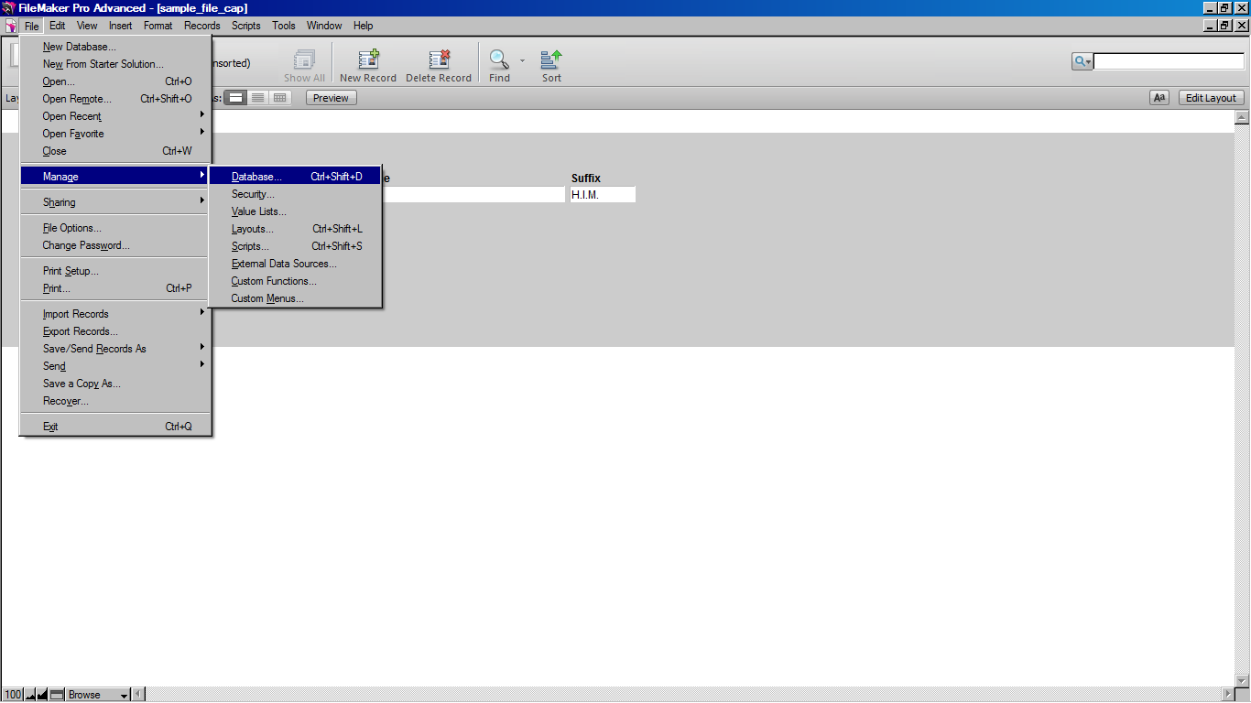

1. Tables tab
2. Type: payments (name of table)
3. Click Create button
4. Double click payments table (or click fields tab)

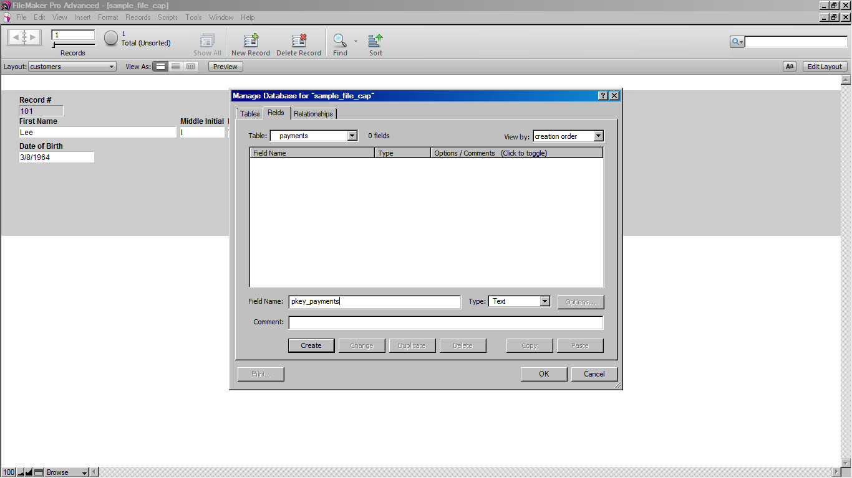

1. On the fields tab, type the field name: pkey_payments
2. Text (data type)
3. Click Create button
4. Options button/auto-enter tab

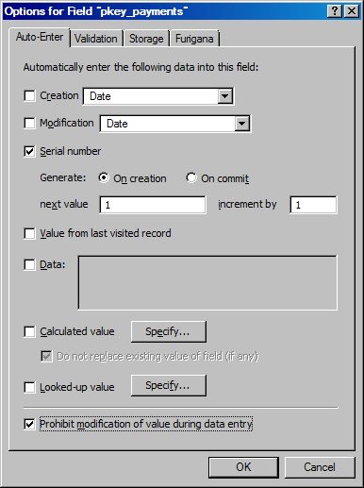

1. Click Serial number option button
2. Click Prohibit modification of value during data entry (so that the primary key for a record cannot be changed)/Click OK
3. Create other fields, remembering to click the **Create** button after typing each one.
   1. fkey_customer (type = text). This field is the foreign key.
   2. pay_date (type = date)
   3. pay_amount (type = number)

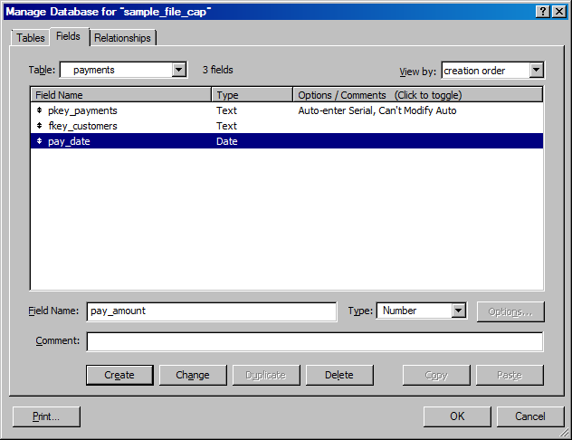

1. pay_type (type = text)
2. Click Create button.

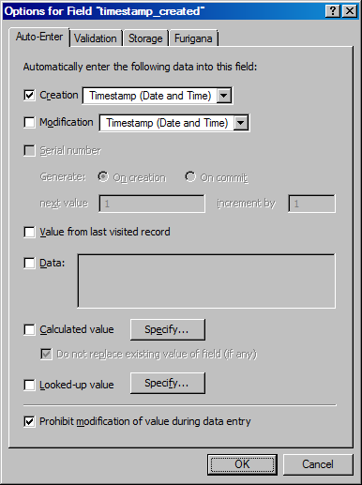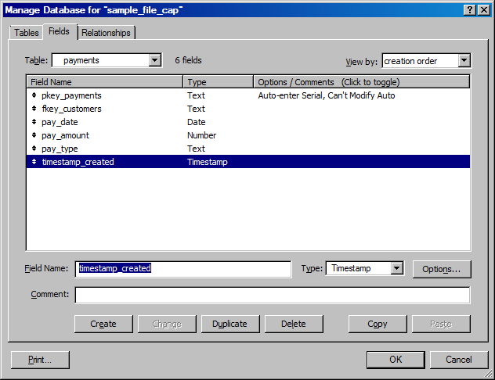

1. timestamp_created (type = Timestamp)/Click Create button.
   1. options button/Auto-Enter tab
   2. Creation checkbox/timestamp (Date and Time)
   3. Prohibit modification of value during data entry/Click OK
2. timestamp_modified (type = Timestamp)/Click Create button.
   1. options button/Auto-Enter tab
   2. Modification checkbox/timestamp (Date and Time)
   3. 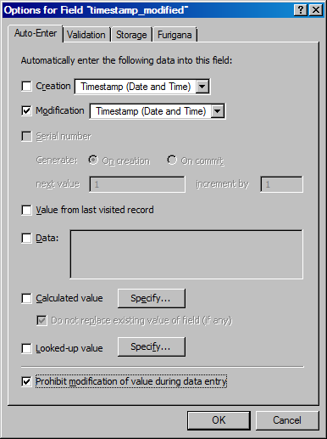Prohibit modification of value during data entry/Click OK

# Creating Relationship between customers and payments table

1. Relationships tab
2. Click the **sample_database** table.

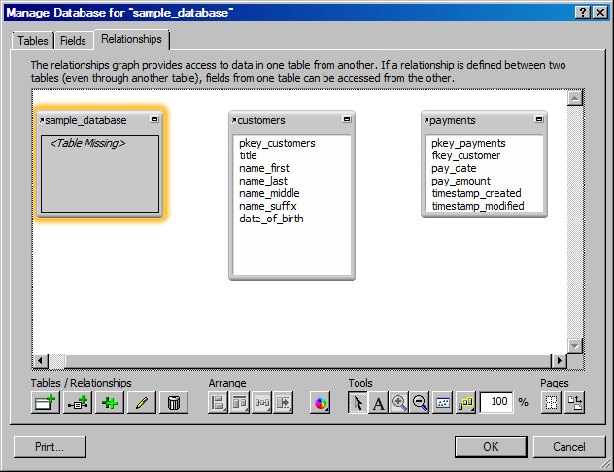

1. Using the Delete button, delete the sample_database.
2. Click Remove.

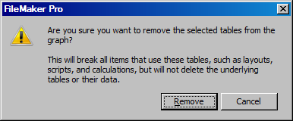

1. Drag pkey_customers (from customers table) to fkey_customers (in payments table)

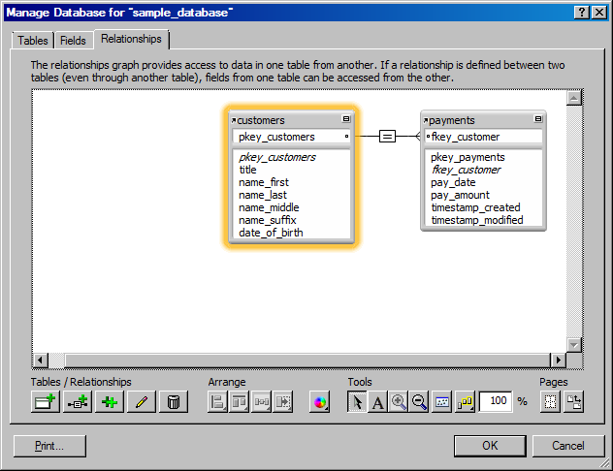

1. Click on equal sign button in middle
2. Click Edit relationships (pencil icon)

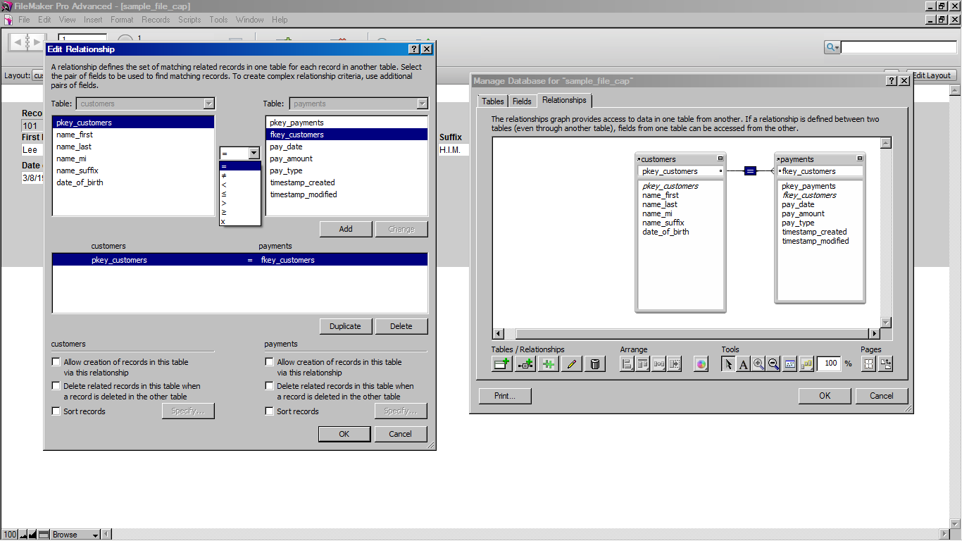

1. Check all three check boxes (under Payments)

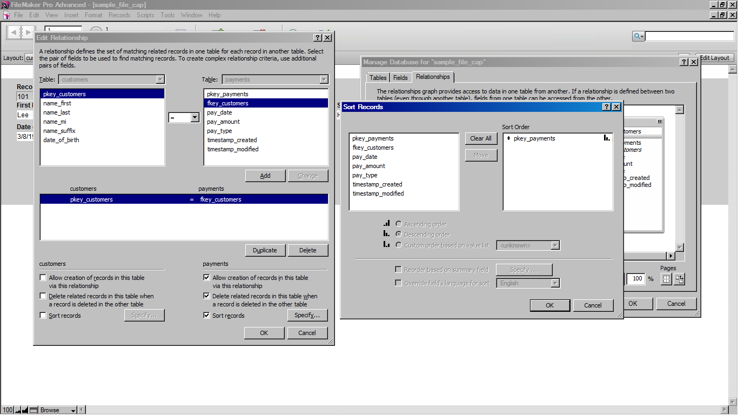

1. Double click on pkey_payments in Sort records window. Sort order is now by pkey_payments.
2. Click OK/OK/OK

Now we will change the mode to **layout mode** so the fields from the payment table can be added to the layout.

1. View menu/layout mode (or click the Mode button at the bottom left corner of screen)

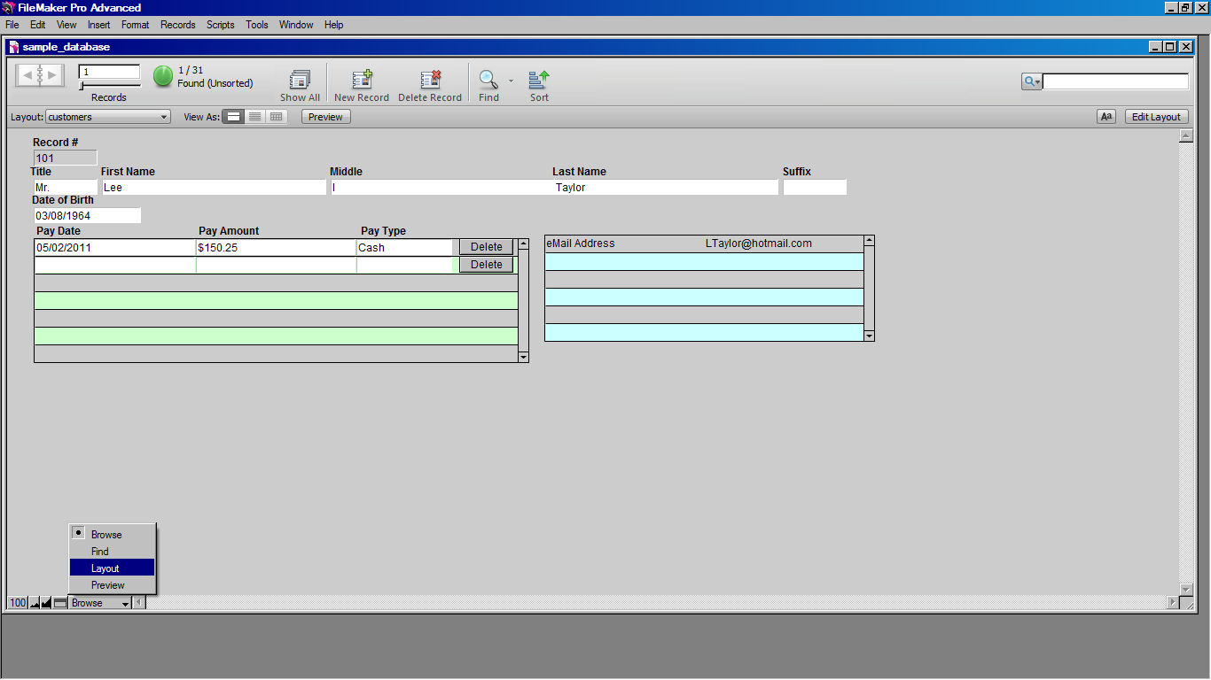

1. Click the Portal tool button

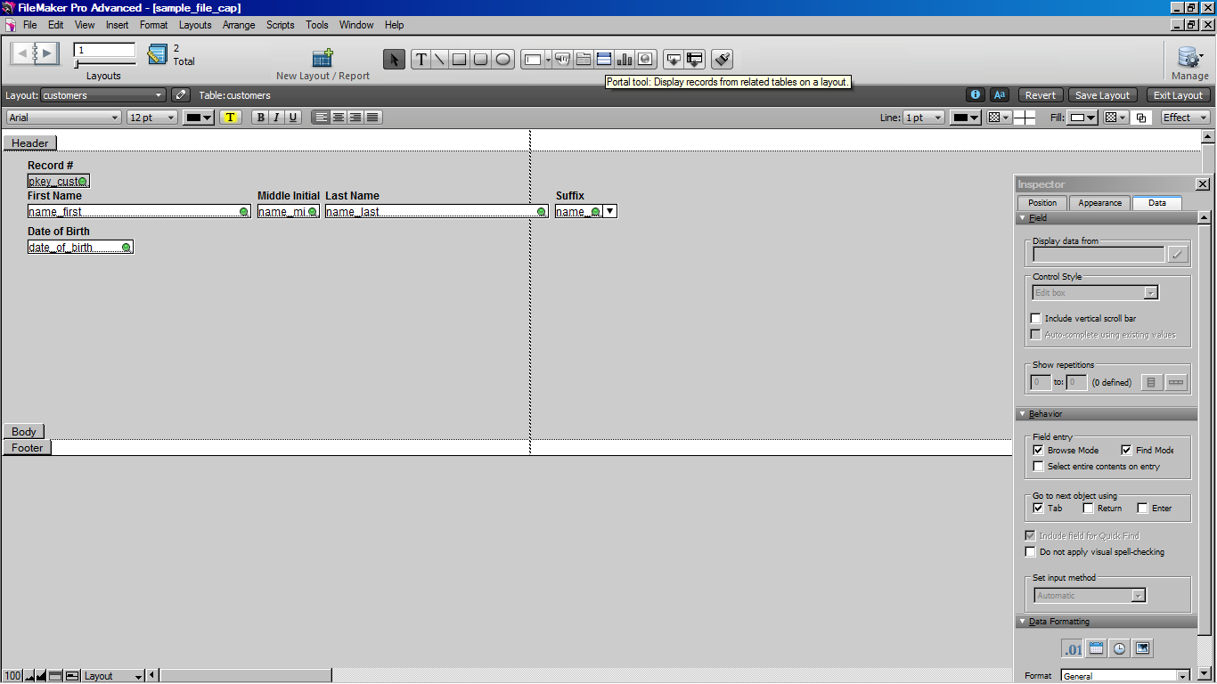

1. Drag a rectangle under Date of Birth field
2. Show related records from **payments** table

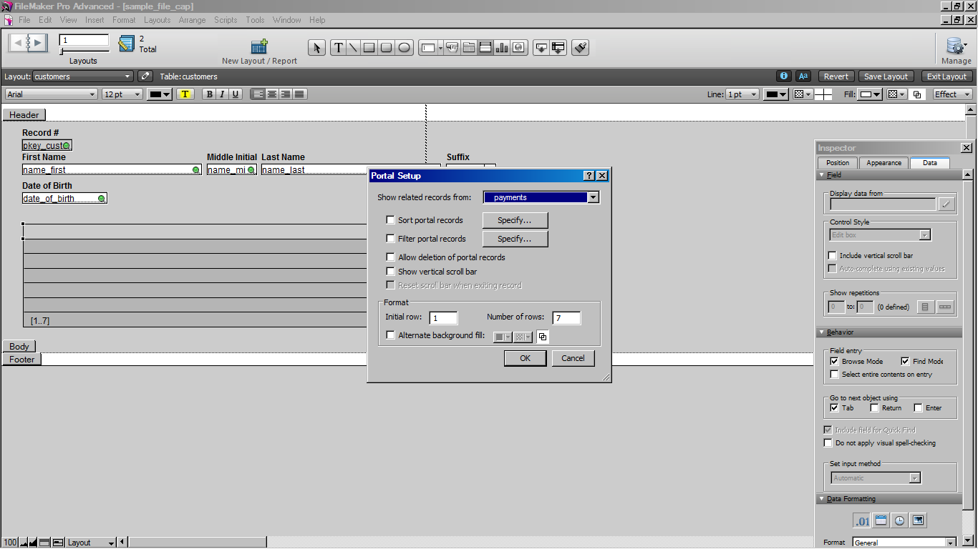

1. Allow deletion of portal records
2. Show vertical scroll bar
3. Number of rows: 7

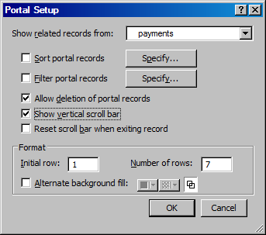

1. Alternate background fill color (pick any light color in drop down arrow)
2. Click OK and click YES to increase size of layout (if prompted by a dialog box)
3. Add fields to portal by double clicking the following fields:
   * pay_date
   * pay_amount
   * pay_type
4. Click OK

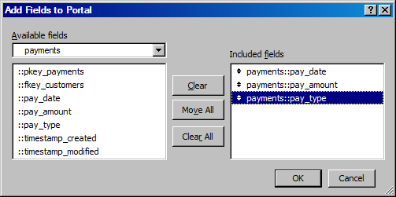

Now we will create labels for the payment fields.

1. Copy one of the labels from above (i.e. Last Name)

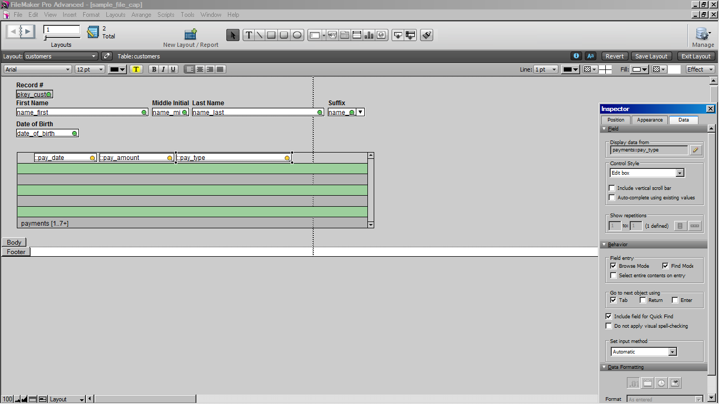

1. Paste above pay_date field, and type **Pay Date.**
2. Do the same to make labels for pay_amount field and pay_type field.
   * Names: **Pay Amount, Pay Type**
3. Select all payment labels (Shift click to select all 3 together).
4. Arrange menu/Align/Bottom Edges.
5. Select the pay_date field, pay_amount field, and pay_type field. (Shift click)
   * 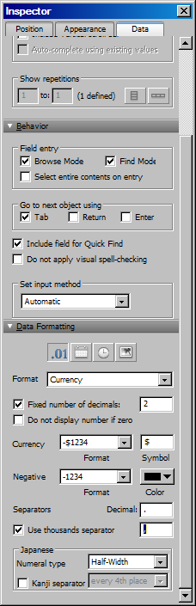Change fill color to White.
   * Effects/Engraved
6. Click pay_amount field
   * Use Inspector/Data tab
     + Change format to Currency
     + Check Fixed number of decimals, 2
     + Check thousands separator
7. Click **pay_date** field
   * Use Inspector/Data tab
     + Change format to mm/dd/yyyy
     + Select Zero in “For day numbers” and “For month numbers”

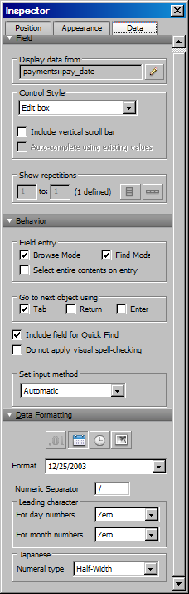

1. Create a Drop-Down List for the pay_type field
   * NOTE: Refer to the tutorial on Drop-Down Lists

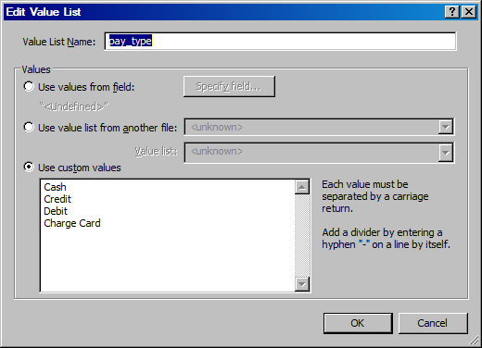

1. In Layout mode, select pay_type field
2. Make changes to the Inspector as pictured below
   * Drop-down list, pay_type, Include arrow to show/hide list

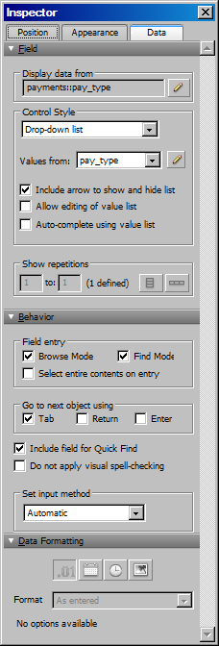

We will now create a button to allow payment records to be deleted (NOTE: This will work ONLY because you selected “Allow deletion of portal records” in Step 31).

1. Click Button tool

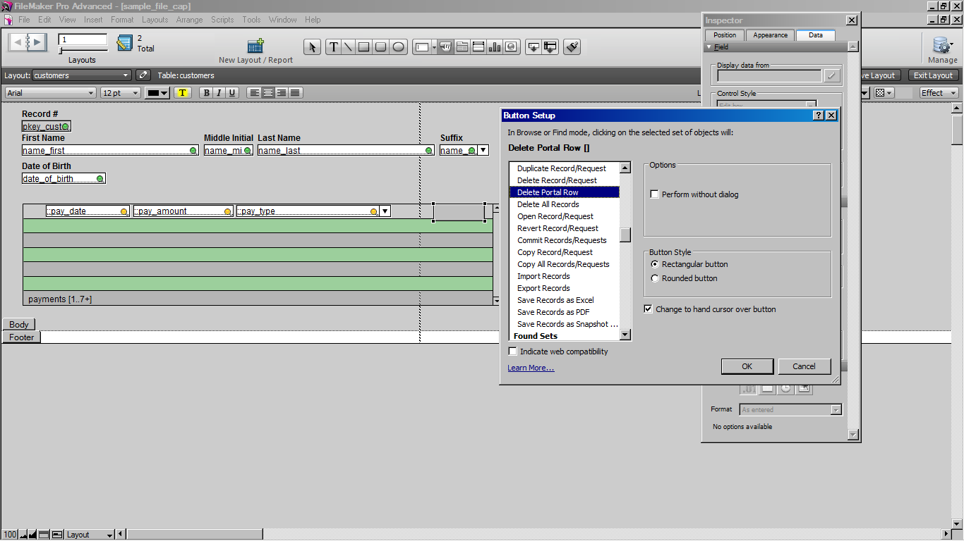

1. Drag to draw the button on right side of pay_type field.
   * (NOTE: Make sure it’s on same row as pay_type, which is on first row of portal)



Uncheck

1. Scroll down, and select “Delete Portal Row”
2. Uncheck “Perform without dialog” (so that a dialog box for “Warn before delete” will appear)
3. Click OK.
4. In the new button, type the name **Delete.**

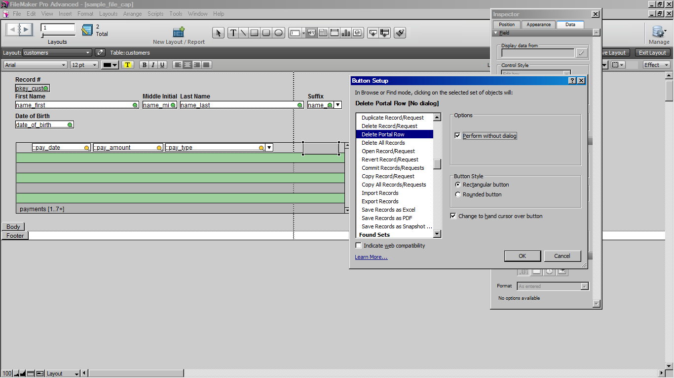

* Click Header and footer buttons and press delete (since no printing in layout mode)

1. Change to Browse mode.
2. Enter a sample payment in the first portal row.

